Haskell Question Set 4
1) Write a function which given a list will return a new list of tuples, with the original values now matched with their
equivalent slot number.
ie: [a, b, c, d] -> [ (0,a), (1,b), (2,c), (3,d) ]
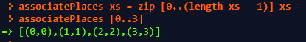
2) Write a function which given a list will return a new list of tuples, with the original values now matched with their
reversed slot location (n-slot#, where n is the length of the slot).
ie: [a, b, c, d] -> [ (4,a), (3,b), (2,c), (1,d) ]
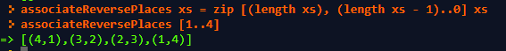

3) Write a function which accepts one list of team names and generates every possible matchup of teams, including both
home and away games.
ie: [a, b, c] -> [ (a,b), (a,c), (b,a), (b,c), (c,a), (c,b) ]

4) Write a function that given two arrays pairs the arrays values with the second list backwards.
ie: [a, b, c] & [e, f, g] -> [ (a,g), (b,f), (c,e) ]
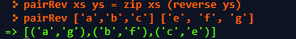

5) Given a list of tuples which contain coordinates, return only the tuples which coordinates are within a distance of 5
from the origin (the distance formula on them and (0,0) is less than 5).

6) Generate a list of tuples which contains the letters A-Z in the first part of the pair and their ascii values as the second
part of the pair. The ascii value of a pairing can only be found if you import Data.Char (ord) then use the ord command
on a letter. So, ord 'A' = 65.
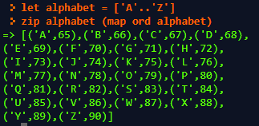

7) Given a list of potential colors (triples), return back a list of only real colors. Colors have all three values in the range
[0,255].
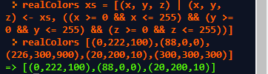

8) Generate a list of all potential chess locations [(a,1), (a,2), (a,3), ...] Chess columns are labeled a-h and chess rows are
labeled 1-8.
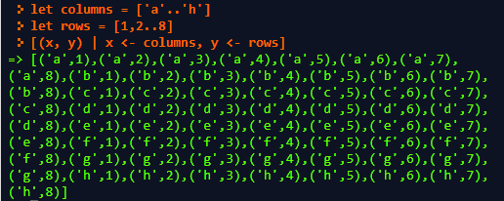

9) Write a function that generates a list of all possible triangles in a given range x, y. Three side lengths can form a
triangle only if the sum of each pair of side lengths is greater than the third side.
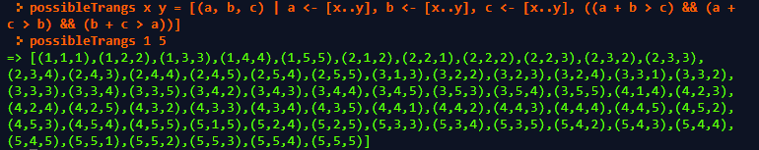
10) Write a function that strips a list of tuples down only to its second values. ie: [(a,b), (b,c), (e,f), (a,a)] -> [b, c, f, a]
Ramping up the difficulty...
11) Write a function which accepts a list and returns back a mapping of the list's unique values to the number of items
that were in the list.
ie: [3, 3, 1, 4, 3, 5, 5, 2, 1] -> [(3,3), (1,2), (4, 1), (5,2)]
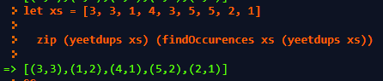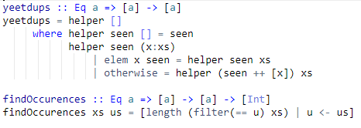
12) Write a function which given a string will return a hashcode of that string computed by summing each ascii value in
the string multiplied by 31^(n-i+1) value, where n is the length of the string and i is the slot number. For instance: "dog"
-> 'd' * 31^2 + 'o' * 31^1 + 'g' * 31 ^ 0. To get the ascii value of any char, you will need to add: import Data.Char (ord) to
the top of your file, then the function ord x will calculate the ascii value of any char. ord 'A' = 65 for instance. I
recommend you split this into separate functions.
13) Write a function which given a list of strings will return a new list of tuples, mapping the hashcode of the string to its
actual value.
